Technical

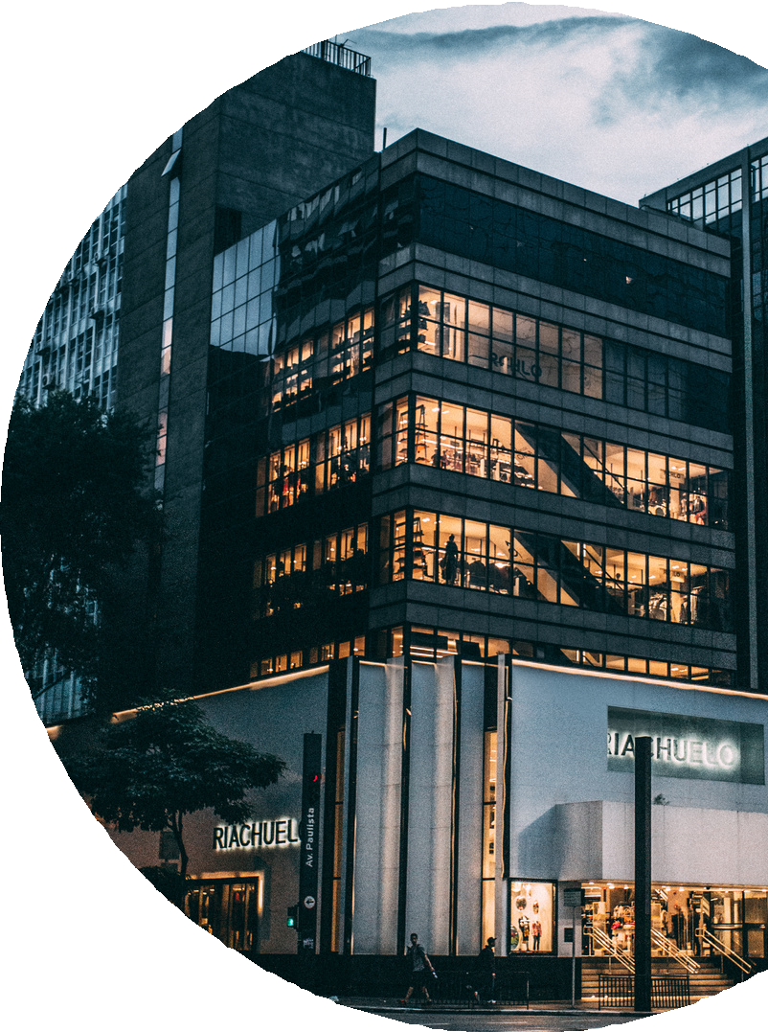

report

2024-2025

**Sensor integration:**

The system was coded using JavaScript and python as a programming language, And NODE.JS was used as an IDE for JavaScript and Vs code for python.

Libraries such as **React and React boost strap** were used to form the front-end of the website [ dashboard]

Libraries such as **Express** for performing and making the server, **Node serial port** that is used to connect between the Arduino and server and **Read line parser** library is used to display the readings sent from the Arduino.

Also, **Sequelize** for making the database and storing the readings every two seconds, **Socket.IO** is used to enable bidirectional and event-based communication between the browser and the server as it connects between the server and the website (dashboard).

The Arduino was coded using the **Arduino IDE** to be the connection between the software prototype and the hardware one.

Hardware: the connections of the circuit as shown in figure ():

Dht22 pins:

1-negative to 5v

2-positive to GND

3-pin 6 to the Arduino

Accelerometer pins:

1-SCL to A5

2-SDA to A4

3-VCC to 5V

4-GND to GND

Ultrasonic pins:

1-5V to 5V

2-GND to GND

3-echo to board pin 3

4-trigger to board pin 2

Sensor integration:

The proposed Structural Health Monitoring (SHM) system provides critical information regarding significant changes or damage to structures. This system monitors three key parameters: vibrations, cracks, and humidity, delivering real-time data updates every 2 seconds.

The data will be displayed on a dashboard and will trigger audible alerts when specific thresholds are exceeded. For example, the vibration threshold is set at 0.0508 m/s, The humidity threshold ranges from 70% to 100% furthermore when the threshold reached the alarm of sound notification of (warning, warning vibration velocity or humidity has reached its threshold ) will turn on, Cracks are monitored, and their width increases over time due to the cumulative effects of vibrations on the structure, prompting an audible alert when the threshold for cracks is detected. Also on the dash board, the readings represented by graphs or in the detection of cracks the logo convert to red color when it reached its threshold as show in the following figures:

**Figure 1**

**Dash board before alert system is turned on:**

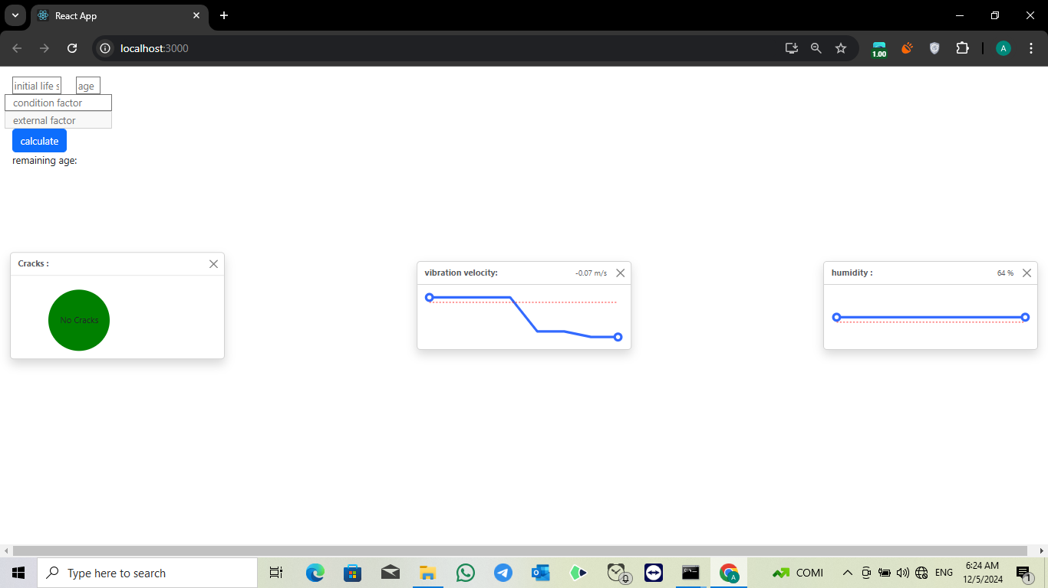

The graph of vibration threshold the graph of humidity threshold

Figure: 2 figure :3

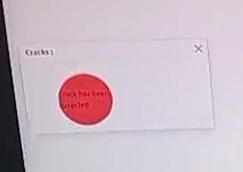

The threshold of detecting crack

Figure :3